`The Structure, Properties and Uses of Graphite

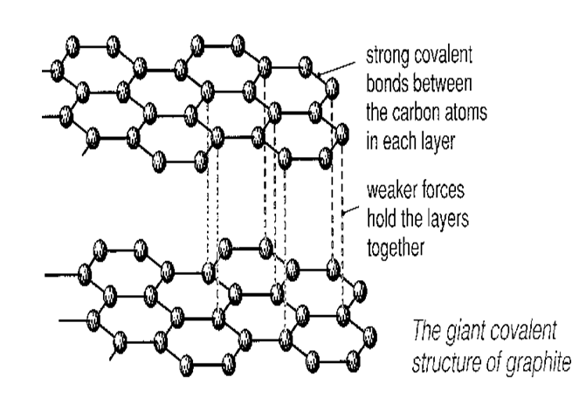 | Description of graphite  eg. How many bonds does each C have? What kind of bonds?  Describe the unusually shaped structure.  __________________________________  __________________________________  __________________________________  ______________________________________________________________________________________________________

Properties | Reason for this property
Melting point: | There are 3 strong covalent bonds, but one weaker bond
Hardness:

Electrical conductivity:

Uses | Reason for this use
Lubricant

